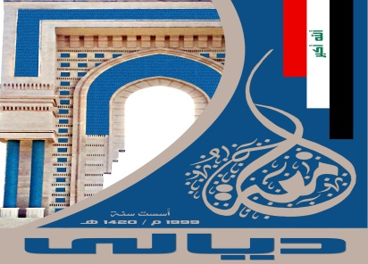

**Ministry of Higher Education and Scientific Research**

**University of Diyala**

**College of Education for Human Sciences**

**Department of Arabic Language**

**ASPECTS OF STYLISTIC DEVIATION**

**IN**

**ANDALUSIAN POETRY**

**(Poets of Age of Al-Tawa'if Kings and Al-Murabiteen)**

**To the council of College of Education for Humanities-**

**University of Dyala As a partial fulfillment of Ph. D**

**degree requirements in Arabic Language & Literature.**

**A Dissertation submitted by:**

**Lu'ai Saih**ood Fawwaz

Under supervision of:

Prof. Dr. Khaleel Ibraheem Abdul-Wahhab

**1436 A.H. 2014 A.D.**

Abstract

This dissertation is an attempt to study aspects of stylistic deviation in the poetic genre, in an introduction and three chapters. The introduction is dedicated to deal with the different terms and Arabic translations of stylistic deviation.

The first chapter tackles "Substitutional Deviation", in three sections:

Section one: Deviation of characterization structure.

Section two: Deviation of simile structure.

Section three: Deviation of impersonation and personification

structure.

The second chapter is devoted to study syntactical deviation, in three sections:

Section one: Metonymic deviation.

Section two: Deviation of hyperbaton, omission and

intertextuality.

Section three: More syntactical deviation aspects, such as:

annexment and shift, apostrophe, interrogation,

order, prohibition, swearing and exclamation.

The third chapter is dedicated to the musical host of the poetical form, with a theoretical introduction and three sections:

Section one: outer music: metres and rhymes.

Section two: inner music in forms of: consonance, repetition,

fronting, isocolon and lionine rhyme.

Section three: Terza rima (Al-Muwashah).

The dissertation has come up

to a conclusion summarizing the final academic results.

***THE RESEARCHER***